Press Release
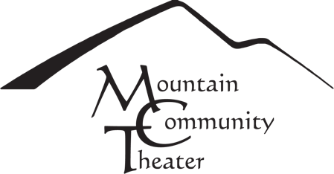

March 1, 2023
For Release: Immediate

MCT Announces the first show of their 41st Season
Tony Award Winning
The Humans by Stephen Karam
March 17 – April 9, 2023
ALL PERFORMANCES WILL BE HELD
At Park Hall in Ben Lomond, 9400 Mill Street

Friday, March 17 @ 8 PM | Saturday, 18 @ 8 PM  Community Night, 2 for $25 | Sunday, March 19 @ 2 PM
Friday, March 24 @ 8 PM | Saturday, March 25 @ 8 PM | Sunday, March 26 @ 2 PM
Friday, March 31 @ 8 PM | Saturday, April 1 @ 8 PM | Sunday, April 2 @ 2 PM  Talk back after the performance
Friday, April 7 @ 8 PM | Saturday, April 8 @ 8 PM | Sunday April 9 @ 2 PM

Mountain Community Theater proudly presents The Humans by Stephen Karam, directed by Miguel Reyna, with performances at Park Hall in Ben Lomond, 9400 Mill Street from March 17th through April 9th. The performances take place on Fridays and Saturdays at 8 PM, with Sunday Matinees at 2 PM. A Community Night performance will be offered on Saturday, March 18th at 8 PM when tickets will be 2 for $25. There will be a talk back on Sunday, April 2nd, after the performance.

The Humans tells the story of the quintessential family reunion–a group of people who love each other but still wrestle with basic human fears: old age, abandonment, poverty, and death. Filled with equal parts humor and hurt, the family explores each other’s familiar idiosyncrasies yet finds a deeper meaning in the struggles of life. The Humans won the 2016 Tony Award for Best Play and was a finalist for the Pulitzer Prize for Best Drama.
Featured performers include Santa Cruz area veteran actors Joyce Michaelson, David Leach, Sarah Kauffman Michael, Solange Marcotte, Davis Banta and Helene Simkin Jara,
with scenic design by Stephen Guildermann-Phillips. Mountain Community Theatre is currently celebrating its 41st year of bringing quality entertainment to Santa Cruz County.

All audience members and house staff must wear masks inside the theater, preferably N95 or KN95 masks; we will have some available at the door if you need one. No bandanas.

For details and tickets www.mctshows.org
###

